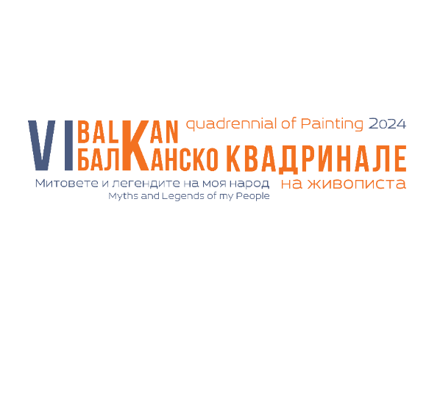

DECLARATION

Of consent of the data subject under the Personal Data Protection Act

THE UNDERSIGNED _______________________________________________________________, IN THE CAPACITY OF _______________________________________________________________
ADDITIONAL INFORMATION _________________________________________________________
(BULSTAT CODE, Personal ID number, UIC )

I hereby declare that I give my consent to Municipality of Stara Zagora, UIC: 000818022 as the administrator of personal data in the capacity of co-facilitator of Balkan Quadrennial of Painting "Myths and Legends of My People" 2024, as well as the facilitators of City Art Gallery - Stara Zagora to process my data solely and only for purposes related to the event.
I understand I have the right to withdraw my consent at any time. I understand that If I withdrawal my consent later it will not affect the legality of the processing which was based on the consent given at the previous time.

DECLARATOR:

DECLARATION

For the temporary and free provision of rights in accordance with Art.18, para. items 1, 6 and 10 of the Copyright and Related Rights

THE UNDERSIGNED: _______________________________________________________________,

ADDRESS: _______________________________________________________________________

EMAIL: __________________________________________________________________________

I hereby declare the following rights to the facilitators of Balkan Quadrennial of Painting "Myths and Legends of My People", 2024, in accordance with Art. 18, para. 1, 6, 10 of Bulgarina Copyright Act:

- I give permission to use my painting/s in printed materials for the organization and promotion of Balkan Quadrennial of Painting "Myths and Legends of My People", 2024. This includes event catalogs, invitations, posters, informational materials, press publications, and any related materials.
- I give permission to use my painting/s in the exhibition halls of City Art Gallery -Stara Zagora, as well in other exhibition halls or events associated Balkan Quadrennial of Painting "Myths and Legends of My People", 2024,
- I give permission to use my painting/s on the Quadrennial’s website or on social media to promote the event. Third parties not affiliated with the quadrennial’s facilitators are prohibited from using it for illegal purposes.

The painting/s can be reproduced, publicly displayed, and accessed online only for purposes related to the organisation and promotion of Balkan Quadrennial of Painting "Myths and Legends of My People" in 2024. However, these activities are subject to the following restrictive conditions:

1. The author reserves all rights to their painting/s. The author temporarily provides rights only for the duration of the Balkan Quadrennial.
2. The facilitators of Balkan Quadrennial of Painting "Myths and Legends of My People", 2024, commit to prominently featuring the artist's name whenever they reproduce or display their artwork.
3. The facilitators of Balkan Quadrennial of Painting "Myths and Legends of My People", 2024, commit to preserving the integrity of the artwork and not altering its appearance.

DECLARATOR :

